**Name: Maitrayee Chakraborty**

**PROJECT 3:**

**Step1: Create two linux instances,Use the first free linux AMI**

**Step2: Launch both instances using Mobaxterm**

**Step3: Host html login webpage on both servers**

**Step4: Check is application is deployed on both servers by copy pasting the public ip of the servers into the browser.**

**Step5: Create a application Load balancer with the above two instances as targets**

**Step6: Check the functioning of ELB**

**SCREENSHOTS:**

Linuxx1 IP address:

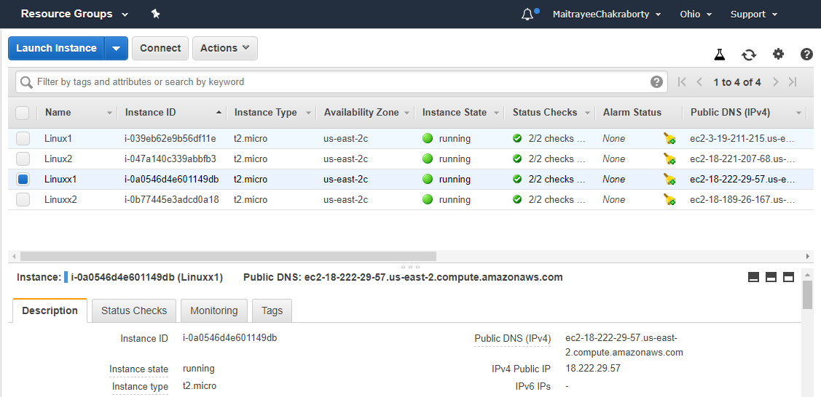

Hosting Linuxx1:

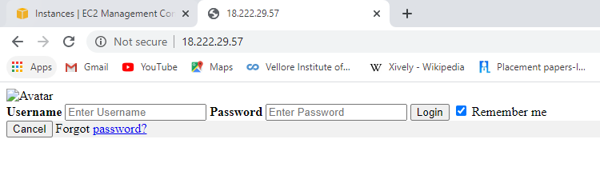

Linuxx2 IP address:

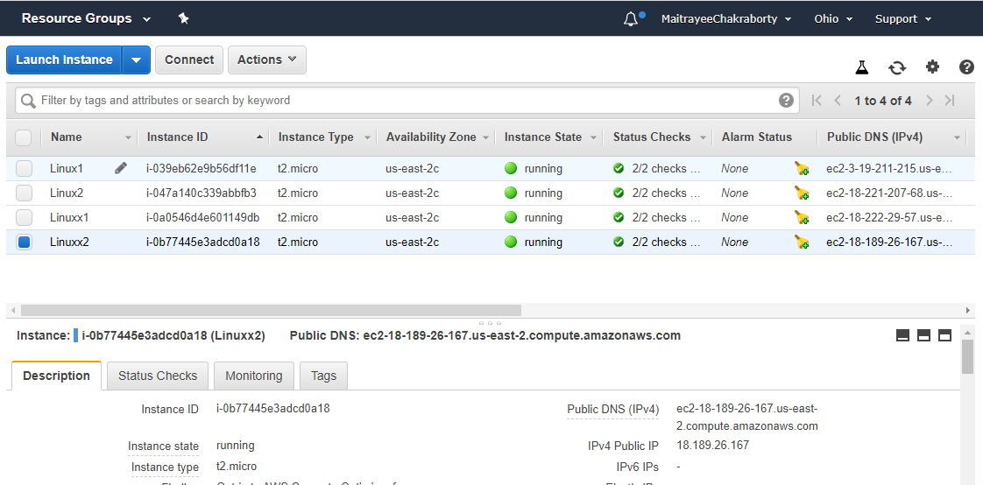

Hosting Linux2:

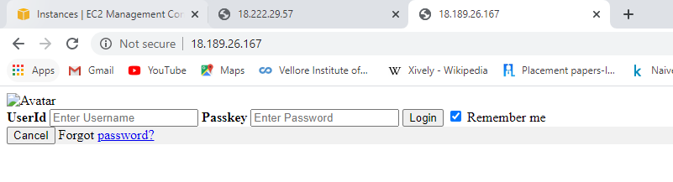

Creating Load-Balancer and the DNS-name:

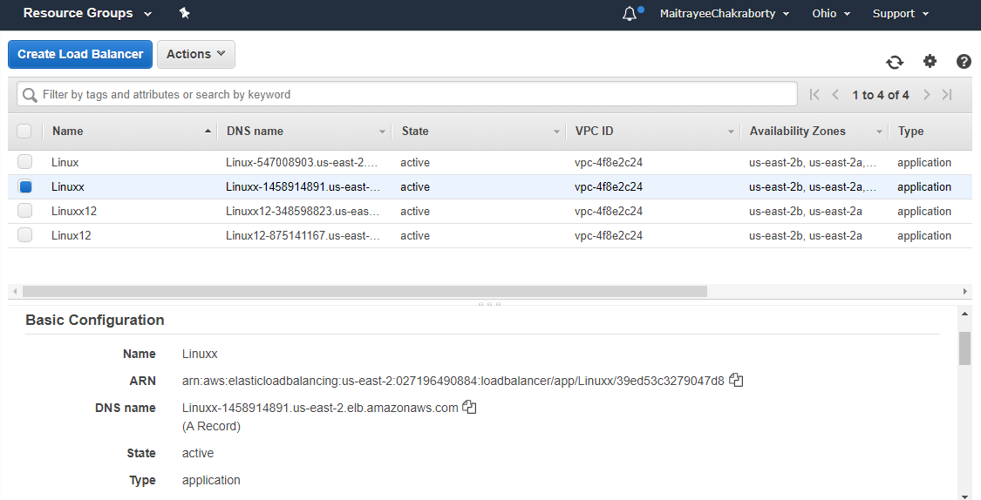

Hosting the DNS:

